Array Orientation in World Coordinates

Sean Reilly - Tuesday, September 25, 2018

The purpose of this paper is to express beam patterns in terms of the sonar array orientation in world coordinates. We believe that this approach will simplify and accelerate the calculation of beam patterns in USML.

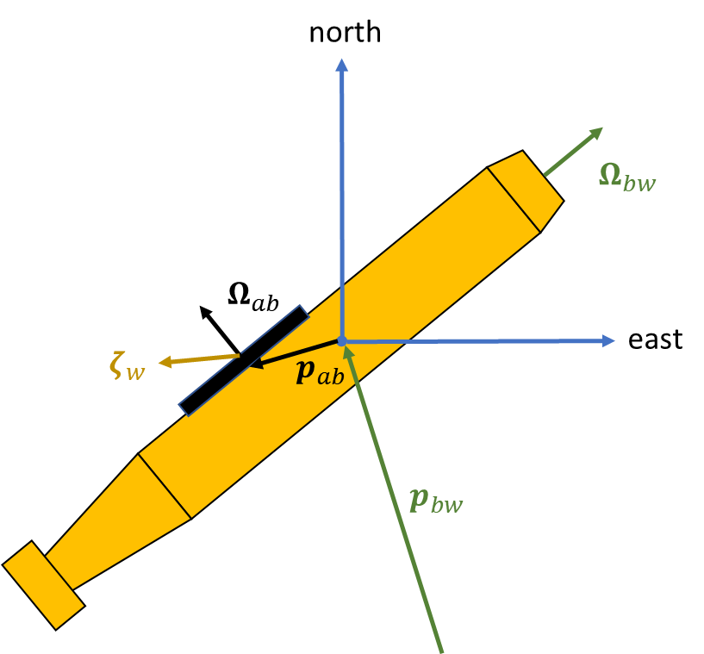

Figure – Illustration of sensor body with a single acoustic array, as seen from above.

The geometry for a single array mounted at an arbitrary point on the sensor body is illustrated in Figure 1 where:

$p_{bw}$ = position vector of the sensor body in world coordinates;

$Ω_{bw}$ = orientation matrix for sensor body in world coordinates;

$p_{ab}$ = position vector of the sensor sonar array in body coordinates;

$Ω_{ab}$ = orientation matrix for sonar array in body coordinates; and

$ζ_{ab}$ = direction vector toward the acoustic signal, in world coordinates.

The orientation of sensor body can be related to yaw ($φ)$, pitch ($μ)$, and roll ($η$) using the Tait–Bryan rotation matrices.[1]

|  |  |  |
| --- | --- | --- |
|  |  | (1) |

|  |  |  |
| --- | --- | --- |
|  |  | (2) |

|  |  |  |
| --- | --- | --- |
|  |  | (3) |

|  |  |  |
| --- | --- | --- |
|  |  | (4) |

The sign on the terms in the rotation matrix and the order in which the rotations are applied have been adjusted to support an orientation in terms of the forward, right, and up axes of the body being rotated.

* Yaw ( $φ)$ moves the front of the object from side to side. A positive yaw angle moves the nose to the right. A yaw value of zero points the object north.
* Pitch ( $μ)$ moves the front of the object up and down. A positive pitch angle raises the front and lowers the back. A yaw value of zero leaves the object parallel to the surface of the earth.
* Roll ($η$) rotates the object around the longitudinal axis, the axis from back to front. A positive roll angle lifts the left side and lowers the right side of the object. In aircraft, a positive roll represents a bank to the right.
* The first column of $Ω_{bw}$ represents direction of the body’s forward vector in the world coordinate system. Similarly, the second column represents the right direction and the third column represents the up direction.

The orientation and position of the array in world coordinates can be computed by chaining the rotation matrices.

|  |  |  |
| --- | --- | --- |
|  | $$Ω_{ab}\left(φ_{a},μ_{a},η_{a}\right)=R_{yaw}\left(φ_{a}\right) R_{pitch}\left(μ_{a}\right) R_{roll}\left(η_{a}\right)$$ | (5) |

|  |  |  |
| --- | --- | --- |
|  |  | (6) |

|  |  |  |
| --- | --- | --- |
|  |  | (7) |

Many beam patterns have simple forms if we express them in terms of the unit vector for the array in the world coordinate system.

|  |  |  |
| --- | --- | --- |
|  | $$Ω_{aw}→\left(n_{aw} , e_{aw} , u_{aw}\right)$$ | (8) |

where

$n_{w}$ = unit vector toward front of array, north if unrotated;

$e_{w}$ = unit vector toward right of array, east if unrotated; and

$u_{w}$ = unit vector toward top (up) of array, up if unrotated.

# Sonobuoy Cosine & Sine Channels

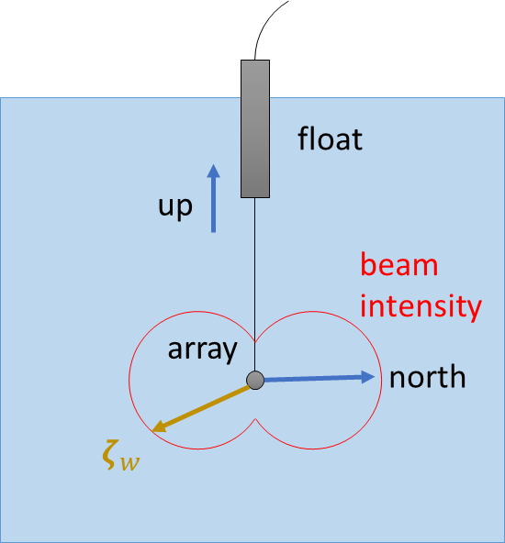

Many sonobuoys support cosine, sine, and omni channels. The beam patterns for the cosine and sine channels can be expressed in the form of a dot product with the direction toward the acoustic signal.[2]

|  |  |  |
| --- | --- | --- |
|  |  | (9) |

|  |  |  |
| --- | --- | --- |
|  |  | (10) |

where $L$ is the null depth in linear units. The location of the sonobuoy body is taken to be the location of the sensor array, not the float from which the sonobuoy descends. The reference axis the sonobuoy channels is changed by changing the yaw of the sonobuoy body.

# Horizontal Line Arrays

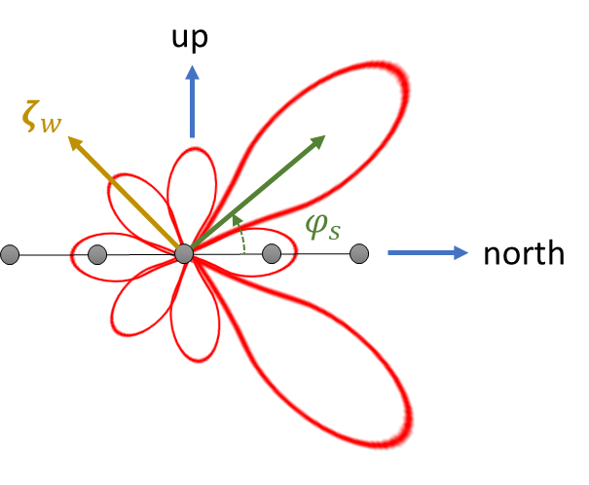

Horizontal line arrays are represented by a line of evenly spaced elements along the $n_{aw}$ axis. Steerings are represented relative to this same axis.

|  |  |  |
| --- | --- | --- |
|  |  | (11) |

where:

$N$ = number of elements;

$d$ = distance between elements;

$c$ = speed of sound in water;

$f$ = signal frequency; and

$φ_{s}$ = azimuthal steering direction from front of array.

# Vertical Line Arrays

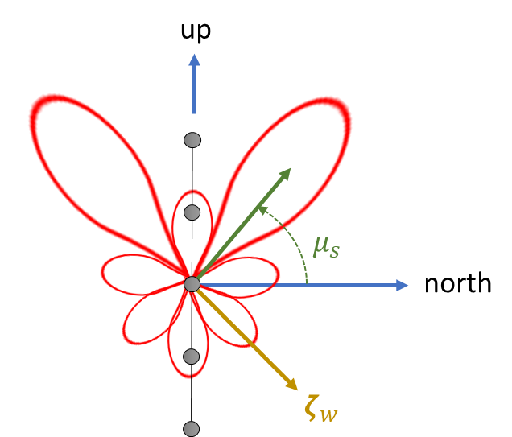

Vertical line arrays are represented by a line of evenly spaced elements along the $u_{aw}$ axis. Steerings are represented normal to this axis.

|  |  |  |
| --- | --- | --- |
|  |  | (12) |

where $μ_{s}$ is the depression/elevation steering.

# Rectangular Planar Arrays

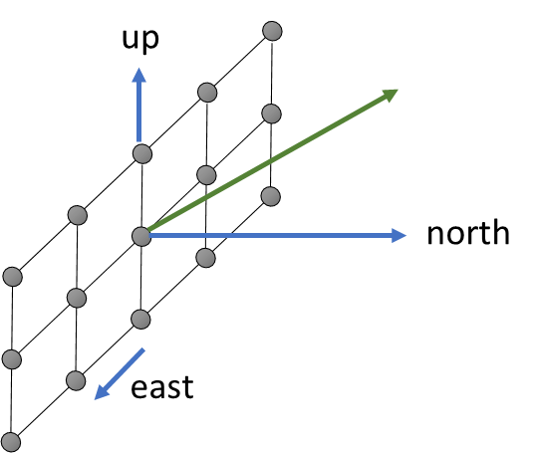

A rectangular planar array can be represented as the product of 2 line array patterns. Steerings are represented normal to the array face along the $n_{aw}$ axis.

|  |  |  |
| --- | --- | --- |
|  |  | (13) |

where:

$N_{u}$ = number of elements in the up-down direction;

$d_{u}$ = distance between elements in the up-down direction;

$N_{e}$ = number of elements in the east-west direction;

$d_{e}$ = distance between elements in the east-west direction;

# Gridded Arrays

A gridded array interpolates the beam pattern as a function of the direction vector toward the acoustic signal for multiple depression/elevation steerings, azimuthal steerings, and frequencies. The direction vector toward the acoustic signal is converted into depression/elevation and azimuthal angles.

|  |  |  |
| --- | --- | --- |
|  | $$μ_{a}=\sin^{-1}\left(ζ_{w}⋅u_{aw}\right)$$ | (14) |

|  |  |  |
| --- | --- | --- |
|  |  | (15) |

where:

$μ_{a}$ = depression/elevation toward the acoustic signal, in array coordinates; and

$φ_{a}$ = azimuthal toward the acoustic signal, in array coordinates.

Gridded arrays area are often computed from the spatial Fourier transform of elements at arbitrary locations. In each dimension, the spatial Fourier transform can be expressed as:

|  |  |  |
| --- | --- | --- |
|  |  | () |

|  |  |  |
| --- | --- | --- |
|  |  | () |

where is the spatial shading of each element. Such computations should also support the ability to include baffle effects stored as an 2D array of gains as a function of $μ_{a}$ and $φ_{a}$.

1. Wikipedia, Davenport chained rotations, <https://en.wikipedia.org/wiki/Davenport_chained_rotations#Tait-Bryan_chained_rotations>
2. Production Sonobuoy Specification for Bathythermograph Transmitting Set AN/SSQ-36B and Sonobuoys AN/SSQ-53F, 62E, 77C, and 101, 10 Sept 2004.